**SAVE THE DATE!**

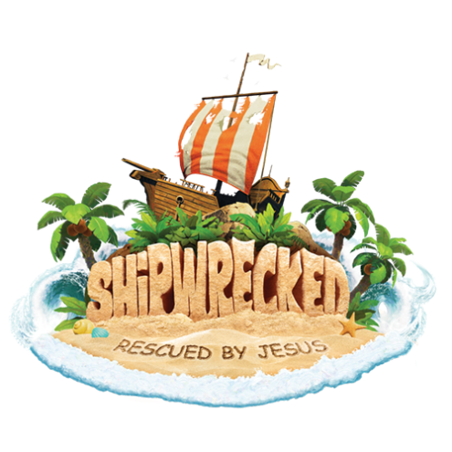

**Vacation Bible School is coming!**

July 9-13, 2018

9 AM to Noon

at Risen Christ Catholic Parish

3060 S. Monaco Parkway, Denver

Registration opens April 9 on the website:

www.risenchristchurch.org